Developing and using mathematical concepts in my day to day experiences.

**Learning outcome:**

Surveying, knowing and distinguishing attributes of objects.

**LESSON 1**

**Competence:**

I can identify relationship and difference between different objects and shapes.

Suggested materials: visual, real objects, chalkboard, cut outs.

**Procedures:**

Discuss with learners about relationships of the shapes.

**Song:**

Am a circle, am a circle

I go around and round

I have no sides

Am a circle am a circle

Am a star, am a star

I shine so bright

I have five pointed sides

Am a star , am a star

**Activity:**

Let the learner colour the shapes.

**LESSON 2**

Learning outcome:

Surveying knowing and distinguishing the attributes of objects.

Competence:

I can identify relationship and differences between different objects and shapes.

Suggested materials: visual , real objects, cut outs

**Procedure:**

Discuss with learners about a song in relationship of shapes.

**Activity:**

Let the learner match the same shapes.

**LESSON 3**

**Learning outcome:**

Surveying, knowing and distinguishing the attributes of objects.

**Competence:**

I can identify relationship and difference between different objects and shapes.

Suggested materials: visual, cut outs, real objects

**Procedure:**

Discuss with learners about relationships of shapes.

Am oval, am ova

I have no side

Am oval am oval

**Activity:**

Let a learner copy and learn the shapes.

|  |  |
| --- | --- |
| Oval |  |
| Circle |  |
| Star |  |

**LESSON 4**

**Learning outcome:**

Surveying, knowing and distinguishing the attributes of objects.

**Competence:**

I can identify relationship and difference between different objects and shapes.

**Activity:**

Let a learner match shapes to objects.

**LESSON 5**

**Learning outcome:**

Surveying , knowing and distinguishing the attributes of objects.

**Competence:**

I can identify relationship and difference between different objects and shapes.

Suggested materials: visual, cut outs, real objects

**Procedure:**

Discuss with learners about relationships of shapes.

Am a circle, am a circle

I go round and round

I have no side

Am a circle am a circle

**Activity:**

Let the a learner name the shapes.

**LESSON 6**

**Learning outcome:**

Surveying, knowing and distinguishing the attributes of objects.

**Competence:**

I can identify relationship and difference between different objects and shapes.

Suggested materials: visual, real shapes, cut outs.

**Procedure;**

Discuss with learners about the relationship of shapes.

**Riddle :**

Am around I have no side

Am like a ball, what am I?

**Riddle:**

I have five pointed sides

I shine at night

Up in the sky what am I?

**Activity:**

Let a learner match words to shapes.

Zig zag

Rectangle

Square

Kite

Crescent

**LESSON 7**

**Learning outcome:**

Surveying, knowing and distinguishing the attributes of objects.

**Competence:**

I can identify relationship and difference between different objects and shapes.

Suggested materials: visual, real shapes, cutouts.

**Procedures:**

Discuss with learners about the relationship of shapes.

**Riddle:**

Am around I have no side

Am like a bowl, what am I?

**Riddle:**

I have five pointed sides

I shine at night

Up in the sky what am I?

**Activity:**

Let a learner circle the word for the shape

Oval triangle circle

Zig zag star circle

Star zig zag square

Rectangle oval star

**LESSON 8**

**Learning outcome:**

Surveying, knowing and distinguishing the attributes of objects.

**Competence:**

I can identify relationship and difference between different objects and shapes.

Suggested materials: visual, real objects, cut outs.

**Procedure:**

Discuss with learners about relationship of shapes.

Am a circle am a circle

I go round and round

I have no side

Am a circle am a circle

**Activity:**

Let a learner fill in

|  |  |
| --- | --- |
| Oval | Ov\_\_\_l |
| Circle | C\_\_rcle |
| Star | St\_\_\_r |

**LESSON 1**

**Learning outcome:**

Recognizing, describing and representing numbers and their relationships and solving mathematical problems with competence and confidence.

**Competence:**

I can count things and numbers

Suggested materials: real objects, counters, chalkboard

**Procedure:**

Discuss with learners about counting things and numbers

**Sing a song**

One yellow duck ---

Swimming in the water x 2

Swim swim swim swimming

In the water

**Activity:**

Let the learner count numbers 0 -5

0, 1, 2, 3, 4, 5

**LESSON 2**

**Learning outcome:**

Recognizing, describing and representing numbers and their relationships and solving mathematical problems with competence and confidence.

**Competence:**

I can count things and numbers.

Suggested materials: visual, real objects, counters.

**Procedure:**

Discuss with learners about counting things and numbers.

**Sing a song:**

1 2 3 4 5 once I caught a fish alive

6 7 8 9 10 then I let it go away

why did you let it go, because

it bit my finger tip which

finger did it bite, the

little finger on my right

**Activity:**

Let a learner match the same.

0 5

1 4

2 3

3 2

4 0

5 1

**LESSON 3**

**Learning outcome:**

Recognizing, describing and representing numbers and their relationships and solving mathematical problems with competence and confidence.

**LESSON 4**

**Learning outcome:**

Recognizing , describing and representing numbers and their relationships and solving mathematical problems with competence and confidence.

**Competence:**

I can count things and numbers.

Suggested materials: real objects, counters, chalk board

Procedures:

Discuss with learners about counting things and numbers.

**Sing a song:**

One yellow duck –

Swimming in the water x2

**Activity:**

Let a leaner count and circle

=

=

=

=

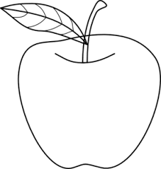 =

**Procedure:**

Discuss with learners about counting things and numbers.

**Sing a song:**

1 2 3 4 5 once I caught a fish alive

6 7 8 9 10 then I let it go away

why did you let it go, because

it bit my finger tip which

finger did it bite, the

little finger on my right

**Activity:**

Let a learner count and match

     1

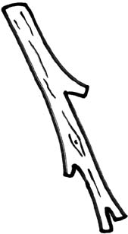    2

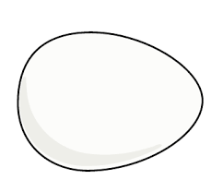  5

SL01040_ SL01040_ 4

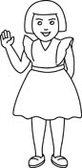 3

**LESSON 5**

**Learning outcome:**

Recognizing , describing and representing numbers and their relationships and solving mathematical problems with competence and confidence

**Competence:**

I can count things and numbers.

Suggested materials: Real objects, counters, chalkboard

**Procedure:**

Discuss with learners about counting things and numbers.

**Sing a song**

Number one x 2

Where are you?

Here I am x 2

How do you do

**Activity:**

Let a learner count and write.

**LESSON 6**

**Learning outcome:**

Recognizing, describing representing numbers and their relationship and solving mathematical problems with competence and confidence.

**Competence:**

I can count things and numbers.

**Suggested materials:** real objects, counters, chalk board

**Procedure:**

Discuss with learners about counting things and numbers

**Sing a song:**

Number one x 2

Where are you?

Here I am x 2

How do you do

Activity:

Let a learner draw for the number.

4 =

3 =

2 =

0 =

1 =

**LESSON 7**

**Learning outcome:**

Recognizing, describing and representing numbers and their relationship and solving mathematical problems with competence and confidence.

**Competence:**

I can count things and numbers

**Suggested materials:** Real objects, counters, chalk board

**Procedure:**

Discuss with learners about counting things and numbers

**Sing a song**

Number one x 2

Where are you?

Here I am x 2

How do you do

**Activity:**

Let the learner shade for the number

5 =

4 =

0 =

6 =

3 =

**LESSON 1**

**Learning outcome:**

Recognizing, describing and using money

**Competence:**

I can identify types of money and their features.

**Suggested materials:** real money, charts, visual

**Procedure:**

Discuss with learners about money.

What is money?

Money is a medium of exchange.

**Rhyme:**

Money! Money! Money! is good

My mother needs money my father

Needs money and I need money too

**Activity:**

Let the learner identify the types of money.

Copy and learn types of money

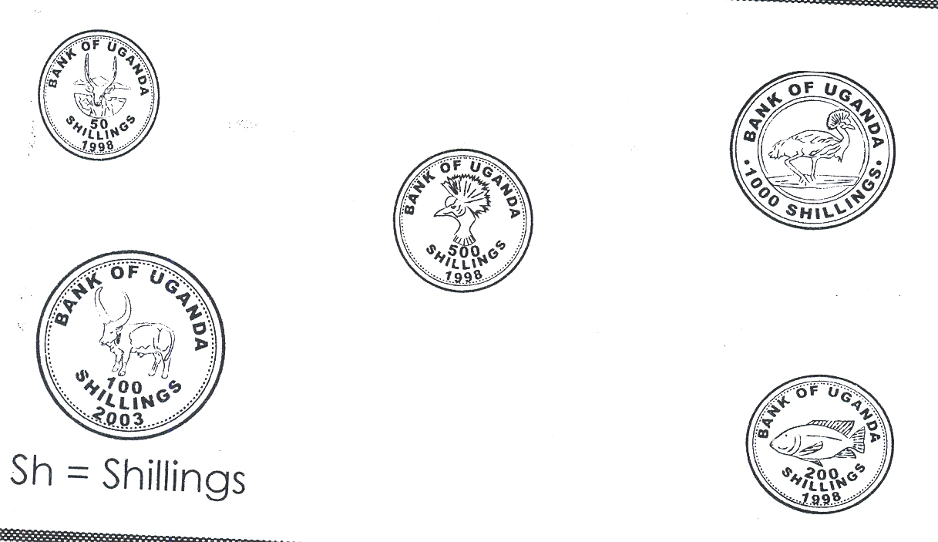 

**LESSON 2**

**Learning outcome:**

Recognizing, describing and using money.

**Competence:**

Identify types of money and their features.

**Suggested materials:** real money, charts, visual

**Procedure:**

Discuss with learners about money

**Poem:**

Money! Money! Money!

Who made you money

In coins we need you

In notes we need you

Money! Money! money!

**Activity:**

Let a learner identify the types of money.

 

**LESSON 3**

**Learning outcome:**

Recognizing, describing and using money.

Competence:

Identify types of money and their features.

**Suggested materials:** real money, charts, visual

**Procedure:**

Discuss with learners about money

Tongue twister

Man made money and money made man mad

**Activity:**

Let the learner identify and match the type of money

 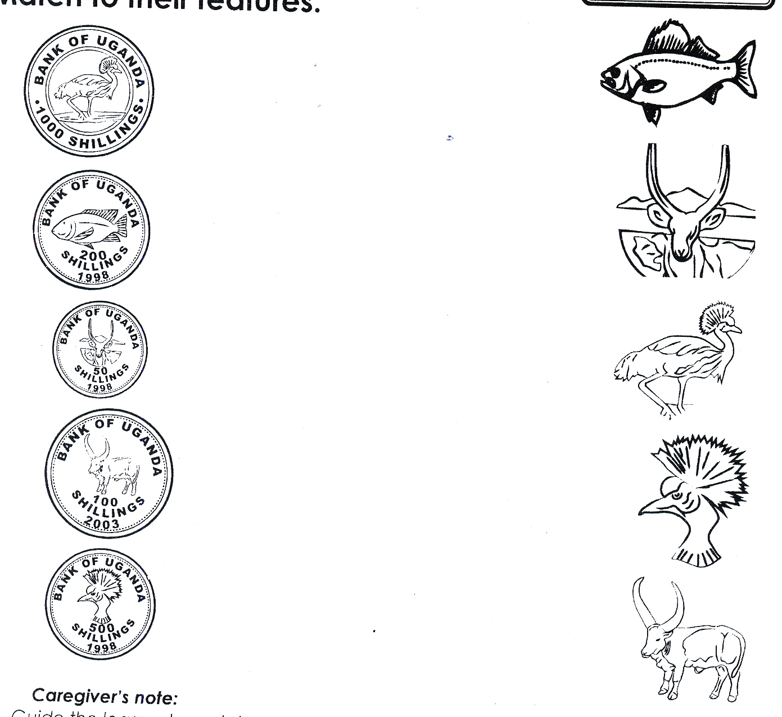

 

 

 

**MOREPRACTICE WORK TERM I**

**LEARNING AREA 4 (NUMBERS)**

**Counting numbers orally. (0-15)**

**Copy**

|  |  |  |  |  |  |  |  |  |  |  |  |
| --- | --- | --- | --- | --- | --- | --- | --- | --- | --- | --- | --- |
| 0 | 1 | 2 | 3 | 4 | 5 | 6 | 7 | 8 | 9 | 10 | 11 |
|  |  |  |  |  |  |  |  |  |  |  |  |
| 12 | 13 | 14 | 15 |
|  |  |  |  |

**Match the same and write**

0 6

1 5

2 0

3 1

4 2

5 3

6 4

0 ------ 2 ----- 4 ------- 6 -------- 8 ------10

**Count and match**

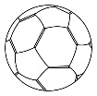    3

  1

   4

 2

**Count and circle**

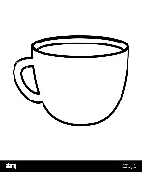  = 1 2

    = 4 6

   = 5 6

     = 7 5

 = 3 1

**Count and write**

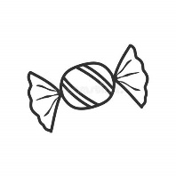 =

     =

  =

   =

      =

    =

         =

**Count and write**

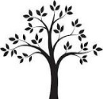  =

    =

 =

      =

**Count and write**

**Draw beads for the given number**

=7 =1 =5

= 3 = 6 = 4

**SHAPES**

**Read and match**

square

oval

triangle

circle

**Match**

star

kite

cone

**Name these shapes**

**Circle the correct word for the shape**

tngleie triangle

circle rcleci

zag-zig zig-zag

kite teki

valo oval

star tars

tanglectre rectangle

cone neco

quares square

**Read and draw**

|  |  |  |
| --- | --- | --- |
| Oval | Circle | Square |
| Triangle | Rectangle | Star |
| Zig-zag | Kite | Cone |

**Fill in the missing letters**

tr---angle sq-----are ov----l h-----art c----rcle

zig-z-----g c---ne st-----r r---ctangle

**Copy the same**

square zig-zag

oval circle

triangle star

cone kite

rectangle

**NUMBER NAMES**

**Copy the same**

0 – zero 1- one 2 – two

3 – three 4 – four 5 – five

6 – six 7 – seven 8 – eight

9 – nine 10 – ten

**Match a number to its number name**

0 five

1 three

2 zero

3 one

4 two

5 four

**Match**

6 ten

7 nine

8 six

9 seven

10 eight

**Write in figures**

Zero \_\_\_\_\_\_\_\_\_ ten \_\_\_\_\_\_\_\_ one \_\_\_\_\_\_\_\_

Three \_\_\_\_\_\_\_\_ four \_\_\_\_\_\_\_\_ six \_\_\_\_\_\_\_\_\_\_

Nine \_\_\_\_\_\_\_ two \_\_\_\_\_\_ five \_\_\_\_\_\_\_\_

Seven \_\_\_\_\_\_ eight \_\_\_\_\_

**Write in words.**

0 \_\_\_\_\_\_\_ 2 \_\_\_\_\_\_\_ 3 \_\_\_\_\_\_\_ 9 \_\_\_\_\_\_\_

1 \_\_\_\_\_\_\_ 6 \_\_\_\_\_\_\_ 7 \_\_\_\_\_\_\_ 4 \_\_\_\_\_\_\_

5 \_\_\_\_\_\_\_ 10\_\_\_\_\_\_\_ 8 \_\_\_\_\_\_\_

**Add the objects.**

**+ =**

**+** **=**

 